Fernando Gonzales-Vigil

Project 2

**Test Plan**

|  |  |  |  |  |  |
| --- | --- | --- | --- | --- | --- |
| Variable / Constant | Test #1 | Test #2 | Test# 3 | Test #4 | Test #5 |
| countryName | Russia | UK | USA | Peru | France |
| userOption | 1 | 2 | 3 | 4 | 8 |
| optionIsValid | true | true | true | true | false |
| userTemp | 26 |  |  |  |  |
| userDistance |  | 10 |  |  |  |
| userWeight |  |  | 97 |  |  |
| tempFahrenheit | 78 |  |  |  |  |
| distMiles |  | 16.00 |  |  |  |
| weightPounds |  |  | 213.4 |  |  |

*Yellow Cells are values by user input

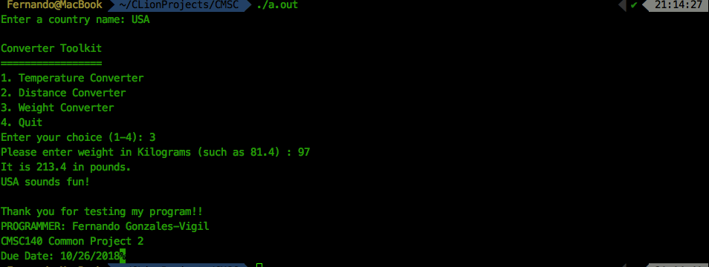

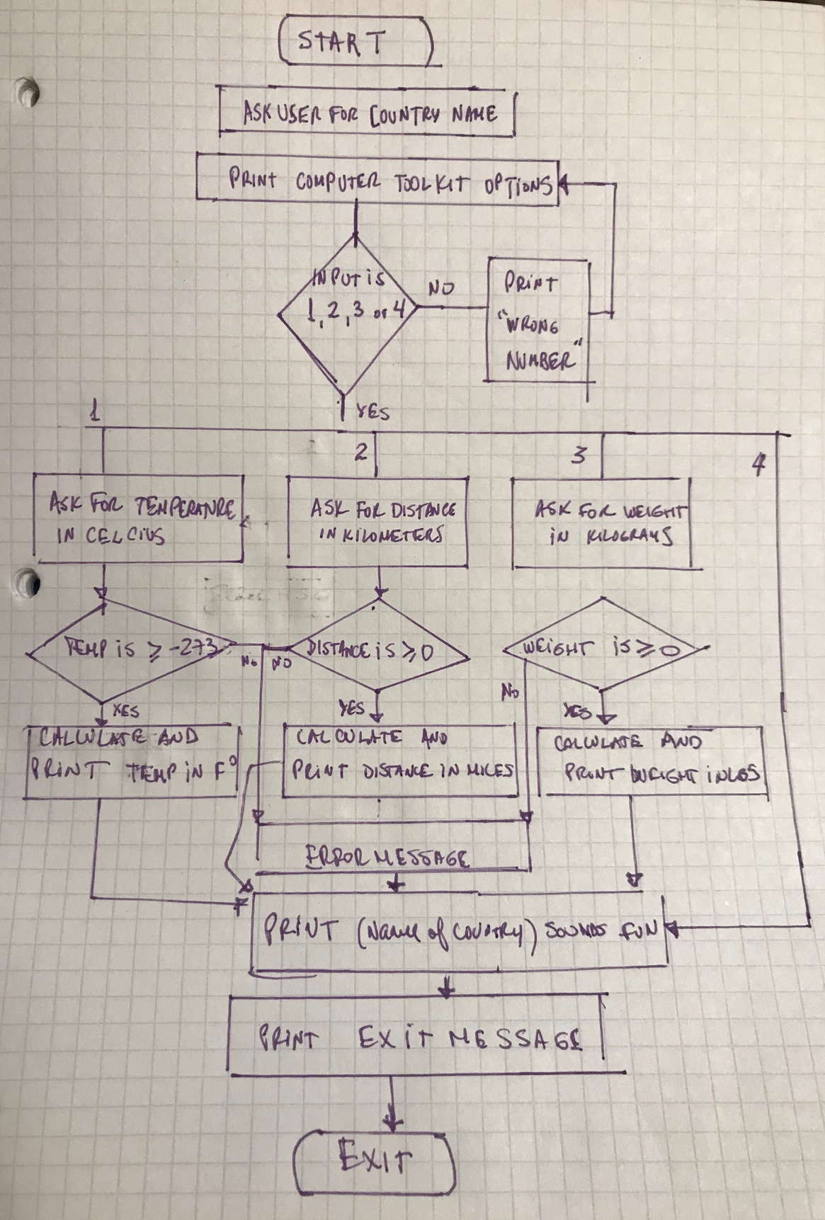

Lesson Learned:

* Infinite loops: While loops are very useful for menus when you need the user to return to the same menu, either because he needs to or because he chose a wrong option. However, you need to be careful of the logic to end exit the while loop or you will find yourself in an infinite loop.
* The code in the switch part could be simplified with functions, in order to be more readable and in that way, allowing the while loop logic to be clearer.